Synopsis
The learning objectives of this seminar are same as that of the lecture for this week. Please if you have not done, watch the lecture before you attempt seminar or do both in parallel. This laboratory session is intended to enable you to understand:
1. Structures
2. Classes and Objects
Answers are provided at the end of this file.

Structures

- A phone number, such as (212) 767-8900, can be thought of as having three parts: the area code (212), the exchange (767), and the number (8900). Write a program that uses a structure to store these three parts of a phone number separately. Call the structure phone. Create two structure variables of type phone. Initialize one, and have the user input a number for the other one. Then display both numbers. The interchange might look like this:

Enter your area code, exchange, and number: 415 555 1212
My number is (212) 767-8900
Your number is (415) 555-1212
- A point on the two-dimensional plane can be represented by two numbers: an x coordinate and a y coordinate. For example, (4,5) represents a point 4 units to the right of the vertical axis, and 5 units up from the horizontal axis. The sum of two points can be defined as a new point whose x coordinate is the sum of the x coordinates of the two points, and whose y coordinate is the sum of the y coordinates.

Write a program that uses a structure called point to model a point. Define three points, and have the user input values to two of them. Then set the third point equal to the sum of the other two, and display the value of the new point. Interaction with the program might look like this:

Enter coordinates for p1: 3 4
Enter coordinates for p2: 5 7
Coordinates of p1+p2 are: 8, 11
- Create a structure called Volume that uses three variables of type Distance to model the volume of a room. Initialize a variable of type Volume to specific dimensions, then calculate the volume it represents, and print out the result. To calculate the volume, convert each dimension from a Distance variable to a variable of type float representing feet and fractions of a foot, and then multiply the resulting three numbers.

Supplementary
- Create a structure called time. Its three members, all type int, should be called hours, minutes, and seconds. Write a program that prompts the user to enter a time value in hours, minutes, and seconds. This can be in 12:59:59 format, or each number can be entered at a separate prompt (“Enter hours:”, and so forth). The program should then store the time in a variable of type struct time, and finally print out the total number of seconds represented by this time value:

long totalsecs = t1.hours*3600 + t1.minutes*60 + t1.seconds

Create a structure called sterling that stores money amounts in the old-style British
system discussed in Exercises 8 and 11 in Chapter 3, “Loops and Decisions.” The members
could be called pounds, shillings, and pence, all of type int. The program should
ask the user to enter a money amount in new-style decimal pounds (type double), convert
it to the old-style system, store it in a variable of type struct sterling, and then
display this amount in pounds-shillings-pence format.

Classes
- Create a class that imitates part of the functionality of the basic data type int. Call the class Int (note different capitalization). The only data in this class is an int variable. Include member functions to initialize an Int to 0, to initialize it to an int value, to display it (it looks just like an int), and to add two Int values.
Write a program that exercises this class by creating one uninitialized and two initialized Int values, adding the two initialized values and placing the response in the uninitialized value, and then displaying this result.
- Imagine a tollbooth at a bridge. Cars passing by the booth are expected to pay a 50 cent toll. Mostly they do, but sometimes a car goes by without paying. The tollbooth keeps track of the number of cars that have gone by, and of the total amount of money collected.

Model this tollbooth with a class called tollBooth. The two data items are a type unsigned int to hold the total number of cars, and a type double to hold the total amount of money collected. A constructor initializes both of these to 0. A member function called payingCar() increments the car total and adds 0.50 to the cash total. Another function, called nopayCar(), increments the car total but adds nothing to the cash total. Finally, a member function called display() displays the two totals. Make appropriate member functions const.

Include a program to test this class. This program should allow the user to push one key to count a paying car, and another to count a nonpaying car. Pushing the Esc key should cause the program to print out the total cars and total cash and then exit.

- Create a class called time that has separate int member data for hours, minutes, and seconds. One constructor should initialize this data to 0, and another should initialize it to fixed values. Another member function should display it, in 11:59:59 format. The final member function should add two objects of type time passed as arguments.

A main() program should create two initialized time objects (should they be const?) and one that isn’t initialized. Then it should add the two initialized values together, leaving the result in the third time variable. Finally it should display the value of this third variable. Make appropriate member functions const.

Answers:
1.
2.
3.
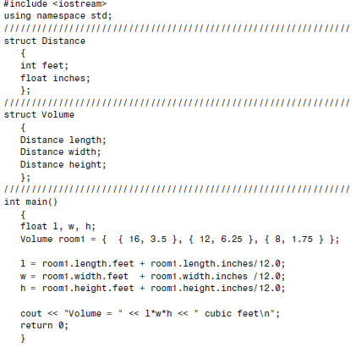
5.
6.

7.

